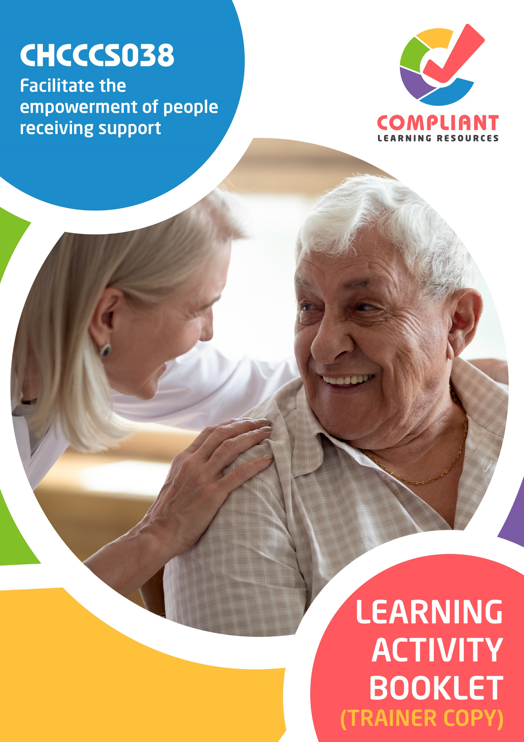

**Copyright**

This document was developed by Compliant Learning Resources.

© 2023 Compliant Learning Resources.

All rights reserved.

No part of this publication may be reproduced, stored in a retrieval system, or transmitted in any form or by any means, electronic, mechanical, photocopying, recording, or otherwise without the prior written permission of Compliant Learning Resources.

**Version Control & Document History**

|  |  |  |
| --- | --- | --- |
| **Date** | **Summary of Modifications** | **Version** |
| 23 December 2022 | Version 1.0 released for publishing | 1.0 |
| 22 August 2023 | Version 1.1  Fixed wording issues | 1.1 |

# Table of Contents

Overview 4

Trainer Instructions 5

Learner Instructions 6

Learner Information 6

Trainer Information 6

Resources Required 7

Work Health and Safety 7

Reasonable Adjustment 8

Contextualisation 9

Formative Activities 10

I. Demonstrate Commitment to Empower People Receiving Support 10

Activity 1.1 10

Activity 1.2 11

Activity 1.3 12

II. Foster Human Rights 14

Activity 2.1 14

Activity 2.2 15

Activity 2.3 17

III. Facilitate Choice and Self-Determination 19

Activity 3.1 19

Activity 3.2 20

# Overview

**CHCCCS038 - Facilitate the empowerment of people receiving support (Release 1)**

This unit describes the performance outcomes, skills and knowledge required to facilitate the empowerment of people receiving support, and to deliver rights-based services using a person-centred approach. It should be carried out in conjunction with individualised plans.

This unit applies to workers in varied care and support contexts.

The skills in this unit must be applied in accordance with Commonwealth and State/Territory legislation, Australian standards and industry codes of practice.

No occupational licensing, certification or specific legislative requirements apply to this unit at the time of publication.

**A complete copy of the above unit of competency can be downloaded from the TGA website:**

<https://training.gov.au/Training/Details/CHCCCS038>

# Trainer Instructions

This Learning Activity Booklet contains formative activities that learners will complete in the classroom or a similar environment.

These formative activities include knowledge questions to test learners’ underpinning generic knowledge and practical activities to test their skills relevant to the unit/s of competency.

These formative assessments are used by trainers to complement both the learning and training processes, and to evaluate how learners are progressing throughout these processes.

**IMPORTANT:**

**The completion of the formative assessments and learning activities included in this workbook DOES NOT lead to a Qualification or a Statement of Attainment (SOA).**

Reasonable adjustment applies here, and while the majority of learners will complete this assessment as a written assessment, verbal assessment may be an option for those who need it. The assessor must use the marking guide as the principal marking tool unless a reasonable adjustment is demonstrated.

The Learning Activity Booklet (Trainer Copy) provides model answers to all the questions, setting out which key responses must be included as well as indicating where flexibility is acceptable.

The number of responses required is specified in each assessment task to avoid ambiguity. In these cases, the model answer will provide a list of possible answers. For instance, if a question requires the learner to list three examples, then their response must include three of the items listed in the model answer.

# Learner Instructions

This Learning Activity Booklet contains formative activities that learners will complete in the classroom or a similar environment.

These formative activities include knowledge questions to test your underpinning generic knowledge and practical activities to test your skills relevant to the unit/s of competency.

These formative assessments are used by your trainer to complement both the learning and training processes, and to evaluate how you are progressing throughout these processes.

You may reference your Learner Guide and other learning materials to complete the activities included in this workbook.

**IMPORTANT:**

**The completion of the formative assessments and learning activities included in this workbook DOES NOT lead to a Qualification or a Statement of Attainment (SOA).**

## Learner Information

|  |  |
| --- | --- |
| Learner name |  |
| Phone |  |
| Email |  |

## Trainer Information

|  |  |
| --- | --- |
| Trainer name |  |
| RTO name |  |
| RTO phone |  |
| RTO email |  |

# Resources Required

Resources needed to complete activities included in this workbook include:

* Computer with Internet, email access, and a working web browser
* Installed software: MS Word, Adobe Acrobat Reader
* Learner guide
* Volunteers to participate in a role play activity

# Work Health and Safety

Both the trainers and learners have duty of care in ensuring that the learning environment is free from hazards that may pose risks to their health and safety.

According to WHS legislation, trainers and learners must take reasonable care while undertaking the activities included in this workbook in the learning environment.

# Reasonable Adjustment

‘Reasonable adjustment’ in VET is the term applied to modifying the learning environment or making changes to the training delivered to assist a learner with a disability. A reasonable adjustment can be as simple as changing classrooms to be closer to amenities or installing a particular type of software on a computer for a person with vision impairment.

**Why make a reasonable adjustment?**

We make reasonable adjustments in VET to make sure that learners with disability have:

* The same learning opportunities as learners without disability, and
* The same opportunity to perform and complete assessments as those without disability.

**Reasonable adjustment applied to participation in teaching, learning, and assessment activities can include:**

* Customising resources and assessment activities within the training package or accredited course
* Modifying the presentation medium
* Learner support
* Use of assistive/adaptive technologies
* Making information accessible both before enrolment and during the course
* Monitoring the adjustments to ensure learner needs continue to be met

**Assistive/Adaptive Technologies**

Assistive/adaptive technology means ‘software or hardware that has been specifically designed to assist persons with disability in carrying out daily activities’ (World Wide Web Consortium - W3C). It includes screen readers, magnifiers, voice recognition software, alternative keyboards, devices for grasping, visual alert systems and digital note-takers.

*(Adapted Reasonable Adjustment in teaching, learning and assessment for learners with a disability - November 2010 - Prepared by - Queensland VET Development Centre)*

**IMPORTANT:**

**Reasonable adjustment made for collecting learner assessment evidence must not impact the standard expected by the workplace, as expressed by the relevant unit/s of competency. For example, if the assessment were gathering evidence of the learner’s competency in writing, allowing the learner to complete the assessment verbally would not be a valid assessment method. The method of assessment used by any reasonable adjustment must still meet the competency requirements.**

# Contextualisation

Contextualisation is the process of modifying assessment tools to make learning more meaningful for your students and their employers.

Compliant Learning Resources highly recommends that your RTO contextualise the assessment tools before using them.

You must contextualise the assessment tools to suit:

* Your student’s needs
* Your RTO’s training and assessment processes
* The work and industry context in which you operate

**Contextualising for your state/territory**

The contents of this assessment tool are not written for a specific state/territory unless stated otherwise. Where the assessment tool refers to legislation and other industry requirements, which may vary across states/territories, model answers are based on one state/territory.

Should your RTO intend to use this assessment tool for learners from your state/territory, Compliant Learning Resources recommends you to:

* Access and review the legislation and industry requirements applicable in your state/territory.
* Update assessments and benchmark answers to reflect the legislation and industry requirements applicable in your state/territory.

When you are contextualising assessment tools, you must ensure that you retain the integrity of the assessment and the outcomes of the unit of competency.

**A comprehensive guide to contextualising your assessment tools for your RTO can be accessed through this link:**

<https://compliantlearningresources.com.au/blog/simple-guide-to-contextualising-rto-training-resources-and-assessment-tools/>

# Formative Activities

## I. Demonstrate Commitment to Empower People Receiving Support

### Activity 1.1

|  |  |
| --- | --- |
| **Matching Type**  Listed below are frameworks for work that involves people receiving support.   1. Legal Frameworks 2. Political Frameworks 3. Structural Frameworks 4. Systemic Frameworks 5. Social Frameworks   Match each to their description below, by writing the letter that corresponds to your answer in the space provided. | |
|  | |
| *Mapping: CHCCCS038 KE1.0 (p), KE1.1 (p), KE1.2 (p)*  *Learner guide reference: CHCCCS038 Learner Guide, Chapter 1, Subchapter 1.1, Section 1.1.4* | |
| Description | |
| d | 1. These are the considerations and standards of practice. |
| a | 1. These are a collection of laws, conditions and arrangements that form the overall legal context. |
| b | 1. These are sets of ideas and rules relevant to management and governance. |
| c | 1. These influence the policies and procedures of an organisation. |
| e | 1. These are the underlying structures that detail the connection of different people. |

### Activity 1.2

|  |  |
| --- | --- |
| **True or False**  Review the statements below about the ethical and legal considerations for working with people receiving support. Indicate whether each statement is True or False.  Tick the box that corresponds to your answer. | |
|  | |
| *Mapping: KE8.1, KE8.4, KE8.7, KE8.9, KE8.10, KE8.11*  *Learner guide reference: CHCCCS038 Learner Guide Chapter 1, Subchapter 1.2, Section 1.2.2* | |
| TRUE  FALSE | 1. A code of conduct is the policy that lays out an organisation‘s principles and standards. It also outlines various expectations that all care workers must adhere to. |
| TRUE  FALSE | 1. Not acting to protect a person from harm does not constitute a breach of duty of care. |
| TRUE  FALSE | 1. Care workers do not need to determine whether a person is suffering from any harm and is in need of immediate help. |
| TRUE  FALSE | 1. Work-role boundaries are used to define your responsibilities when supporting a client. They act as limitations on what the client can ask from you. |
| TRUE  FALSE | 1. Work health and safety practices ensure the safety of you, the person and those involved in their care. This means protection against illnesses and harm from elements in the immediate environment. |
| TRUE  FALSE | 1. Adherence to standards is voluntary, even when they are referred to in legislation. |

### Activity 1.3

|  |
| --- |
| **SCENARIO**  You are the aged care worker for Kate Dawson, an older patient living with dementia. Kate has difficulty understanding other people during conversations. In your last meeting with Kate, she shared that she has a hard time understanding you as you talk really fast. She often feels embarrassed and does not feel comfortable sharing her needs with you. |

|  |
| --- |
| Briefly explain how you can adjust your approach based on the feedback given by Kate. |
|  |
| *Mapping: CHCCCS038 PC1.2 (p)*  *Learner guide reference: CHCCCS038 Learner Guide, Chapter 1, Subchapter 1.2, Section 1.2.3*  **Marking guide**  The learner must briefly explain how they can adjust their approach based on the feedback given by Kate.  For a satisfactory performance, although the wording may slightly vary, their response must be actions they can do to adapt and address their shortcomings based on the feedback given by Kate. An example of a satisfactory response is provided below. |
| I can ask Kate to provide her insights and ideas on how I can adjust my approach to address her needs. I can also communicate with my supervisor, co-workers and other professionals to hear how they dealt with the same problem. |

|  |
| --- |
| List down two ways you can verbally communicate with Kate based on her needs. |
|  |
| *Mapping: CHCCCS038 PC1.2 (p)*  *Learner guide reference: CHCCCS038 Learner Guide, Chapter 1, Subchapter 1.2, Section 1.2.1*  **Marking guide**  The learner must list down two ways they can verbally communicate with Kate based on her needs.  For a satisfactory performance, their responses must be general tips for successful verbal communication. Examples of acceptable responses include:   * Use a tone and pace appropriate to Kate’s needs and abilities. * Avoid the use of discriminatory phrasing. * Ask Kate what will help with communication. * Reword rather than repeat anything that Kate did not understand. * Apologise if I believe that I have embarrassed Kate. |
|  |
|  |

## II. Foster Human Rights

### Activity 2.1

|  |
| --- |
| **Fill in the blanks**  The following are statements on the principles of a human rights-based approach. Review each and complete the statement by filling in the missing words/phrases. |
|  |
| *Mapping: CHCCCS038 PC2.1 (p), KE9.2*  *Learner guide reference: CHCCCS038 Learner Guide, Chapter 2, Subchapter 2.1, Section 2.1.1* |
| 1. Everyone has the right to       participate in decisions that affect their human rights. Participation must be active, accessible and meaningful. It must give attention to issues of       accessibility, including access to information in a form and a language that can be understood. |
| 1. Accountability requires effective       monitoring of compliance with human rights standards and achievement of human rights goals, as well as effective remedies for breaches of human rights. For accountability to be effective, there must be appropriate laws, policies, institutions, administrative procedures and mechanisms of redress in order to secure       human rights. |
| 1. A human rights-based approach means that all forms of discrimination in the realisation of rights must be       prohibited, prevented and eliminated. It also means that priority should be given to people in the most       marginalised or vulnerable situations who face the biggest barriers to realising their rights. |
| 1. Everyone is entitled to claim and exercise their rights and freedoms. Individuals and communities need to be able to       understand their rights and to fully participate in the development of       policies and practices which affect their lives. |
| 1. A human rights-based approach requires that the law recognises human rights and freedoms as       legally enforceable entitlements, and the law itself is       consistent with human rights principles. |

### Activity 2.2

|  |  |  |  |  |  |  |  |  |  |
| --- | --- | --- | --- | --- | --- | --- | --- | --- | --- |
| **Matching Type**  Identify the genetic disorders being described in each statement below.   |  | | --- | | **Genetic Disorders** | | Attention Deficit Hyperactivity Disorder | | Down Syndrome | | Cri du Chat Syndrome | | Cystic Fibrosis | | Fragile X Syndrome | | Huntington’s Disease | | Sickle Cell Disease | | |
|  | |
| *Mapping: CHCCCS038 PC2.2 (p), KE7.1(p)*  *Learner guide reference: CHCCCS038 Learner Guide, Chapter 2, Subchapter 2.2, Section 2.2.1* | |
| Description | |
| Down Syndrome | 1. This is a chromosomal condition affecting chromosome 21. Around 1 in 800 to 1 in 1,000 infants are born with this disorder. |
| Cystic Fibrosis | 1. It is a common but dangerous genetic disease. This disorder causes the body to produce viscous mucus that can clog a person’s lungs. |
| Sickle Cell Disease | 1. It is an inherited red blood cell disorder caused by a genetic mutation. Persons with this disorder have their red blood cells destroyed faster than they can be replaced, causing anaemia. |

|  |  |
| --- | --- |
| Description | |
| Attention Deficit Hyperactivity Disorder | 1. This disorder is a common neurological disorder that affects, mood, behaviour, learning and social interaction. It primarily affects a person’s self-regulation and attention span. |
| Huntington’s Disease | 1. This is an inherited neurological illness. Patients with this disorder experience involuntary movements, severe emotional disturbance, and rapid cognitive decline. |
| Cri du Chat Syndrome | 1. This is a rare genetic condition. It is characterised by a high-pitched cat-like cry that diminishes with age and intellectual disability. |
| Fragile X Syndrome | 1. This is an inherited intellectual disability cause by a mutation in the FMR1 gene. This disorder is characterised by a particular facial appearance, which includes having a large head. |

### Activity 2.3

|  |
| --- |
| **SCENARIO**  You have been assigned to be the disability support worker of Sia Lakshmi, who is a very religious woman of the Hindu faith. For you to provide appropriate support, you must consult with Sia to identify her cultural needs.  Prior to the consultation, you review Sia’s individualised plan. It is noted that Sia prefers to converse in Tamil. As such, you request for a professional interpreter to be onsite during your consultation with Sia. |

|  |
| --- |
| **Role Play Activity**  Role play the scenario with two volunteer to consult with the client to confirm their cultural needs while demonstrating the practical skills listed in the checklist below.  Perform this activity while being observed by your trainer. If your trainer is not available to directly observe you, you may video record the role play activity and submit the recording to your trainer.  **Your role**  For this activity, you will take the role of the disability support worker.  **The volunteers’ role**  For this activity, the volunteers will take the role of:   * The client * The professional interpreter |

|  |
| --- |
| *Mapping: CHCCCS038 PC2.3 (p), PE1.6 (p)*  *Learner guide reference: CHCCCS038 Learner Guide, Chapter 2, Subchapter 2.3, Section 2.3.1*  **Marking guide**  The learner must role play the scenario provided above while demonstrating the practical skills listed below and while being observed by the trainer. The trainer must use the checklist below to evaluate the learner’s performance during the activity. |

|  |  |  |
| --- | --- | --- |
| **Role Play Checklist** (For trainer’s use only) | | |
| **During the role play activity:** | **YES** | **NO** |
| 1. The learner demonstrates positive verbal communication by: |  |  |
| * 1. Speaking directly to the client rather than the professional interpreter. |  |  |
| * 1. Avoiding the use of discriminatory phrasing. |  |  |
| * 1. Letting the client know if they have difficulty understanding them. |  |  |
| 1. The learner asks the client questions about their: |  |  |
| * 1. Cultural needs |  |  |
| * 1. Religious observance needs |  |  |
| * 1. Dietary needs |  |  |
| 1. The learner provides information on what support the client can expect from the learner. |  |  |
| 1. The learner provides information on what support the client can expect from the organisation. |  |  |
| Trainer’s overall feedback on the learner’s performance during the role play activity: | | |

## III. Facilitate Choice and Self-Determination

### Activity 3.1

|  |  |
| --- | --- |
| **Matching Type**  Listed below are the assistive technology for daily living activities.   1. Bedpans 2. Anti-slip mats 3. Prosthetic devices 4. Utensil holders 5. Assistive cups and mugs 6. Offloading footwear 7. Fall detectors   Match each to their description below, by writing the letter that corresponds to your answer in the space provided. | |
|  | |
| *Mapping: CHCCCS038 PC3.5 (p), KE12.2 (p), KE12.4 (p), KE12.7 (p), KE12.11 (p), KE12.12 (p), KE12.13 (p)*  *Learner guide reference: CHCCCS038 Learner Guide, Chapter 3, Subchapter 3.5, Section 3.5.1* | |
| Description | |
| g | 1. These are sensors that alert a carer if someone has taken a fall. |
| a | 1. These are receptables used for both urinary and faecal discharge. |
| d | 1. These are for people who find holding utensils challenging. |
| b | 1. These are rubber mats placed inside and outside the shower or bathtub. |
| c | 1. These are devices that imitate the human body’s movement depending on the device’s complexity. |
| f | 1. This is a type of footwear designed to redistribute pressure. |
| e | 1. These are designed to assist a person to drink. |

### Activity 3.2

|  |
| --- |
| List down and describe five impacts of the structural and systemic obstacles on a person’s empowerment. |

|  |  |
| --- | --- |
| *Mapping: CHCCCS038 PC3.7 (p), KE3.1, KE3.2, KE3.3, KE3.6, KE3.7*  *Learner guide reference: CHCCCS038 Learner Guide, Chapter3, Subchapter 3.7, Section 3.7.2*  **Marking guide**  The learner must list down and describe five impacts of the structural and systemic obstacles on a person’s empowerment.  For a satisfactory performance, although the wording may slightly vary, their response must be consistent with the benchmark answers below. | |
| **Impacts of the structural and systemic obstacles on a person’s empowerment** | **Description** |
| Social | The structural and system obstacles harm the person‘s relationships with others. |
| Physical | The structural and system obstacles induce extreme amounts of stress in the person. |
| Emotional | The structural and system obstacles can cause the person to develop self-esteem or mental health issues. |
| Cultural | The structural and system obstacles impact the wellbeing of people from different cultures. |
| Economic | The structural and system obstacles create fewer opportunities for productivity and employment. |

End of Document